**Morse Code**

From Wikipedia, the free encyclopedia

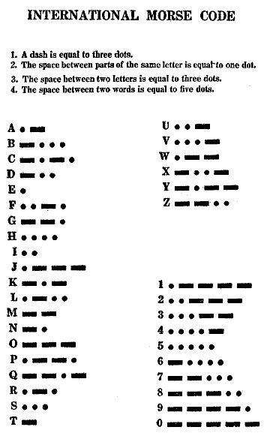

1922 Chart of the Morse Code Letters and Numerals

**Morse code** is a method for transmitting information, using standardized sequences of short and long marks or pulses — commonly known as "dots" and "dashes" — for the letters, numerals, punctuation and special characters of a message. Originally created for [Samuel Morse](http://en.wikipedia.org/wiki/Samuel_Morse)'s electric [telegraph](http://en.wikipedia.org/wiki/Telegraphy) in the mid-1830s, it was also extensively used for early [radio](http://en.wikipedia.org/wiki/Radio) communication beginning in the 1890s. However, with the development of more advanced communications technologies, the widespread use of Morse code is now largely obsolete, apart from emergency use and other specialized purposes, including navigational [radio beacons](http://en.wikipedia.org/wiki/Radio_beacon), land mobile transmitter identification, and by [CW](http://en.wikipedia.org/wiki/Continuous_wave) (continuous wave) [amateur radio operators](http://en.wikipedia.org/wiki/Amateur_radio_operator).

Morse code can be transmitted in a number of ways: originally as electrical pulses along a telegraph wire, but also as an audio tone, as a radio signal with short and long pulses or tones, or as a mechanical or visual signal (e.g. a flashing light) using devices like an [Aldis lamp](http://en.wikipedia.org/wiki/Aldis_lamp) or a [heliograph](http://en.wikipedia.org/wiki/Heliograph). Because Morse code is transmitted using just two states — on and off — it was an early form of a digital code. International Morse code is composed of six elements:

1. short mark, dot or 'dit' (·)
2. longer mark, dash or 'dah' (-)
3. intra-character gap (between the dots and dashes within a character)
4. short gap (between letters)
5. medium gap (between words)
6. long gap (between sentences)

Morse code is the only [digital](http://en.wikipedia.org/wiki/Digital) [modulation](http://en.wikipedia.org/wiki/Modulation) mode designed to be easily read by humans without a computer, making it appropriate for sending automated digital data in voice channels, as well as making it ideal for emergency signaling, such as by way of improvised energy sources that can be easily "keyed" such as by supplying and removing electric power (e.g. by switching a breaker on and off). However, the variable length of the Morse characters made it hard to adapt to automated communication, so it has been largely replaced by more regular formats, including the [Baudot code](http://en.wikipedia.org/wiki/Baudot_code) and [ASCII](http://en.wikipedia.org/wiki/ASCII).

What is called Morse code today actually differs somewhat from what was originally developed by [Alfred Vail](http://en.wikipedia.org/wiki/Alfred_Vail) in collaboration with Morse. In 1848 a refinement of the code sequences, including changes to eleven of the letters, was developed in Germany and eventually adopted as the worldwide standard as "International Morse". Morse's original code specification, largely limited to use in the United States, became known as Railroad or [American Morse code](http://en.wikipedia.org/wiki/American_Morse_code), and is now very rarely used except in some governmental programs/communications.